# 

# **Assessment**

# **SNS SES and Cloudwatch**

Trainee Name : Aditya Upadhyay

Newers ID : 3978

Mentor Name : Tarun Saxena

College : UPES

1. **Monitor Your Estimated Charges Using CloudWatch**

**Step 1: Enable Billing Alerts**

**Step 2: Create a Billing Alarm**

**Step 3: Check the Alarm Status**

**Step 4: Create & Subscribe to SNS Topic**

**Step 5: Send a notification all the stakeholder, if AWS resource pricing reaches the threshold value.**

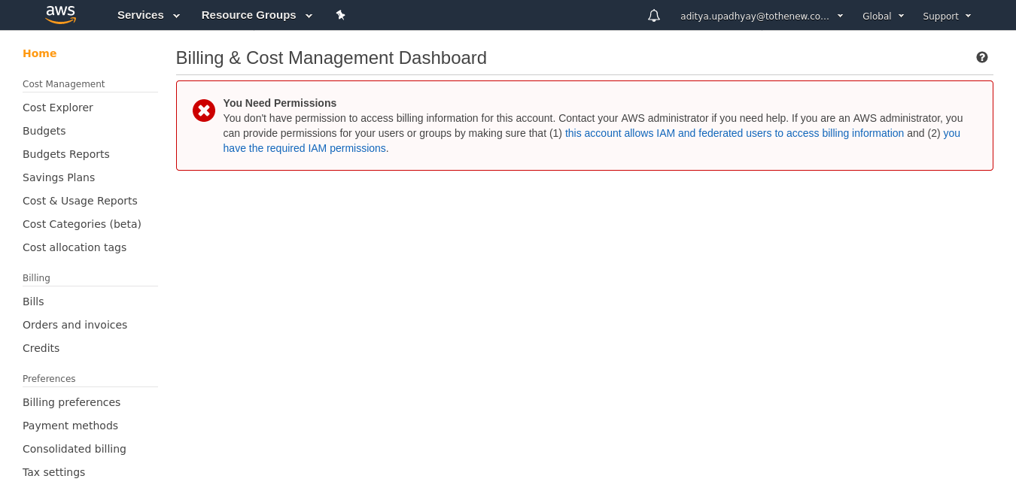

**2. Create a custom Memory metric in CloudWatch and set up alarm at 80 % which will autoscale the instance in the autoscaling group.**

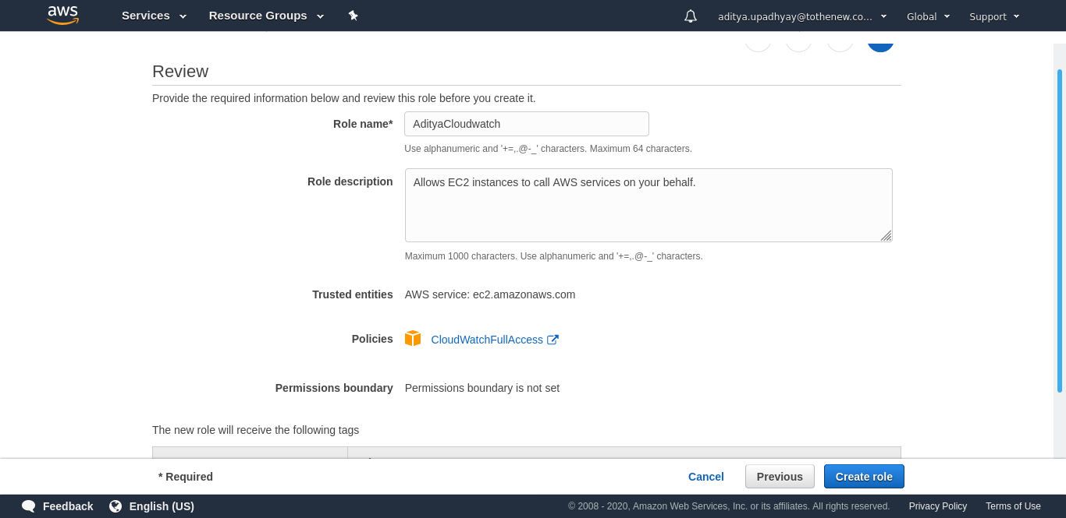

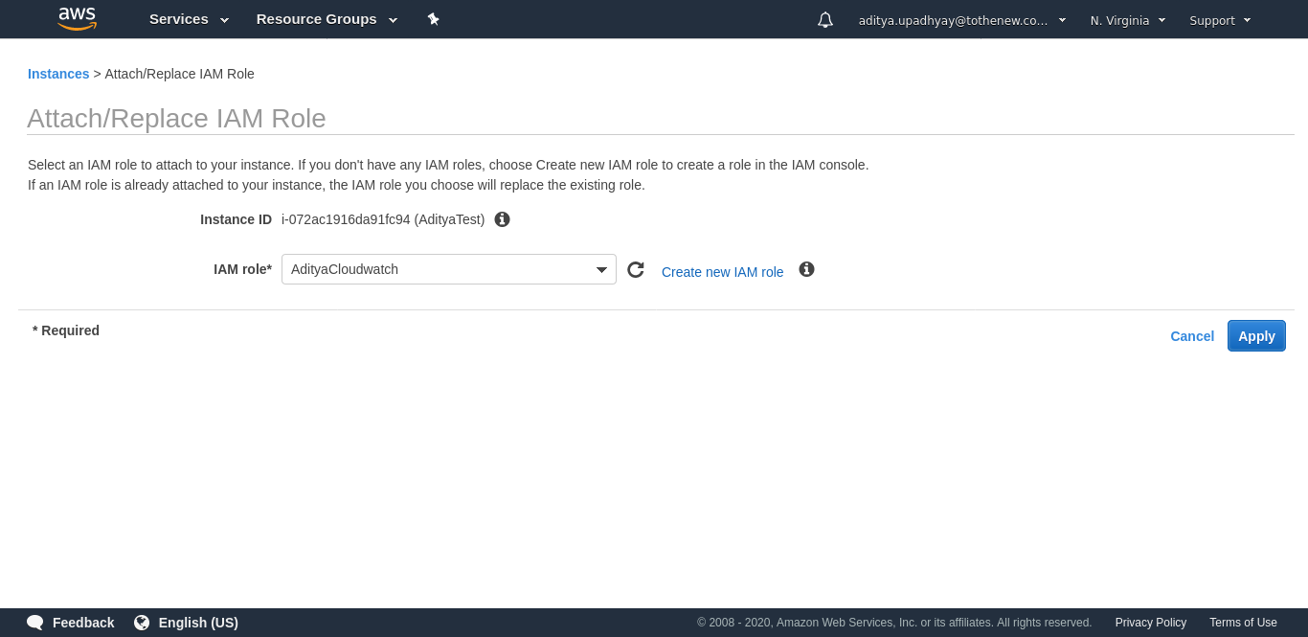

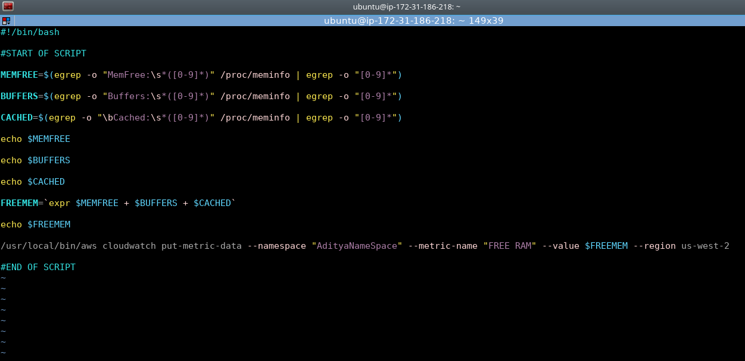

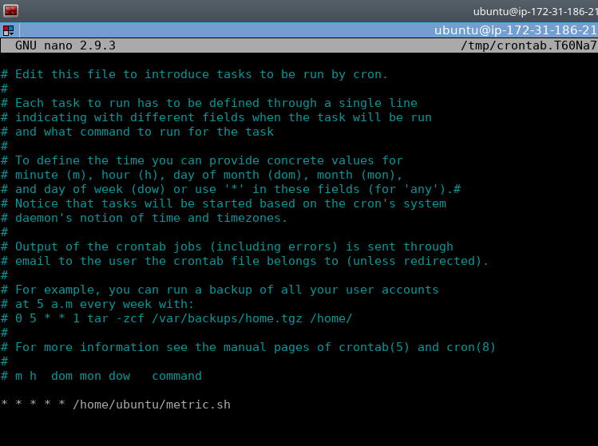

**3. Create SNS topic, subscribe to a topic, publish message, unsubscribe the message and delete the topic.**

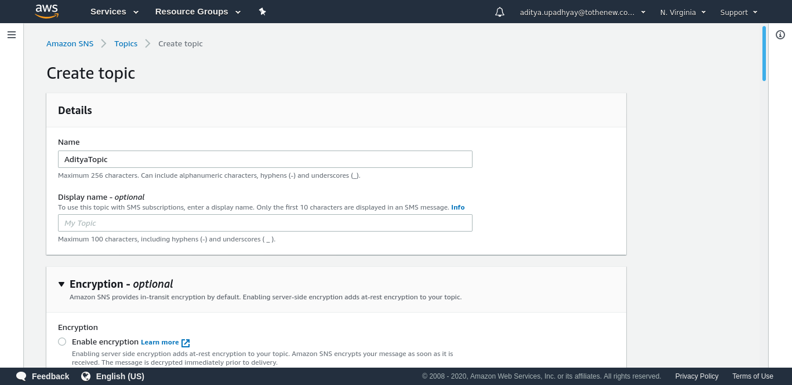

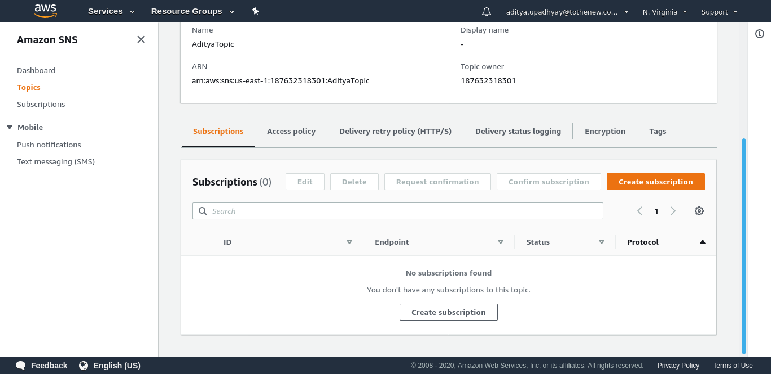

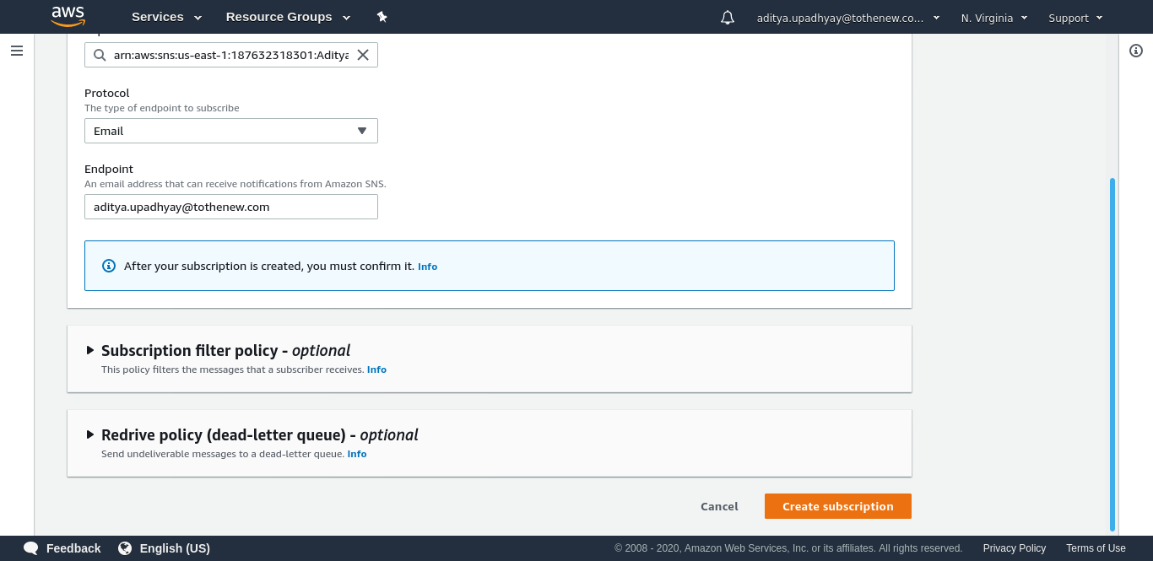

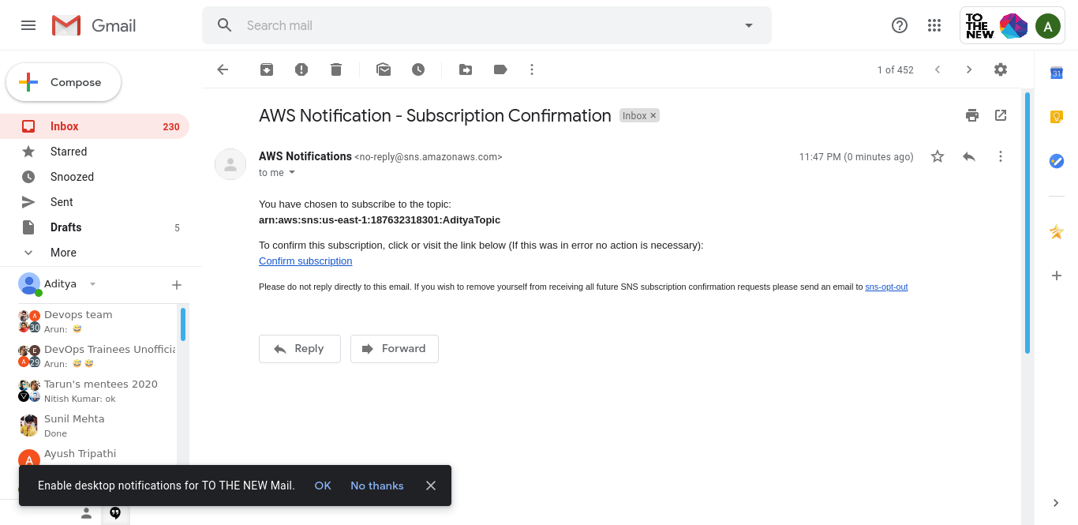



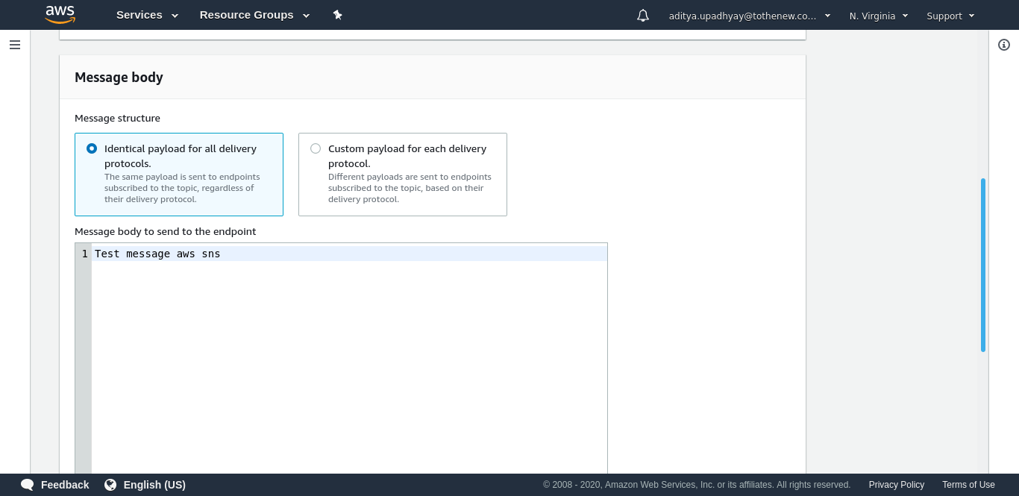

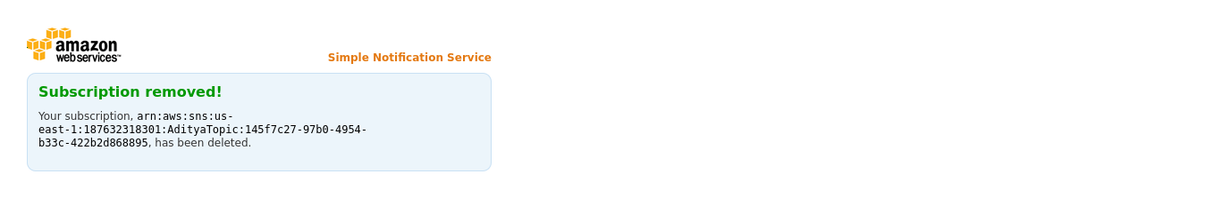

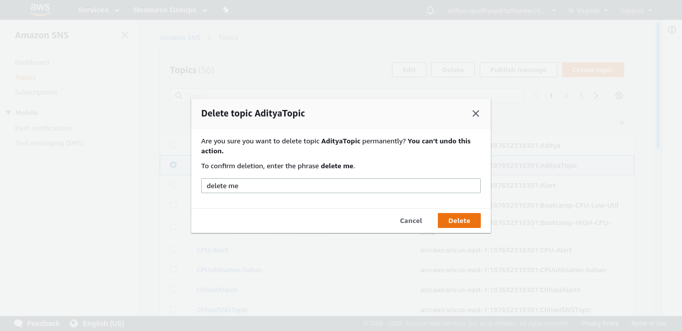

**4. Send a sample mail using SES.**

